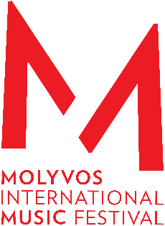


Magical musical moments under a Greek sky

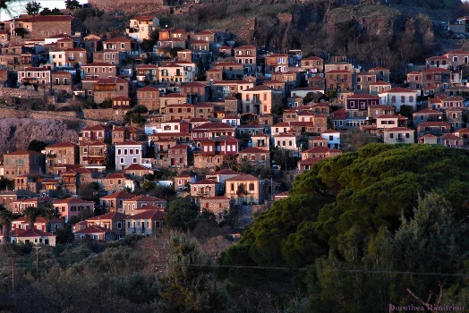
  - From the 12th to the 19th of August 2026, the pianist sisters Danae and Kiveli Dörken will host their Molyvos International Music Festival for the twelfth time on the island of Lesbos – this year entitled HAPPINESS| ΕΥΔΑΙΜΟΝΙΑ with 16 events at unique open-air locations. The chamber music festival’s exciting setlist includes, among others, the Philip Glass tribute "Glass for Two," a choral work by Sven Helbig, and a world premiere by Christos Papageorgiou.

For the twelfth time, sisters Danae and Kiveli Dörken are hosting the Molyvos International Music Festival (MIMF) on the Greek island of Lesbos – with their unique concept of open-air chamber music concerts, some of which are free. The festival offers culture for everyone in an iconic location that, like few others, brings Europe's past and present together under a magnifying glass: the enchanting medieval architecture with its Byzantine castle of Molyvos is contrasted by the still palpable effects of the European refugee crisis. All of this is grounded in the island’s ancient Greek heritage, which can be clearly felt and experiences all around. In 2026, none other than Aristotle lent his name to the festival’s motto: "ΕΥΔΑΙΜΟΝΙΑ," meaning "Happiness" – as the goal, promise, and hope of human nature. The titles of the six concerts point the way: Wisdom (“Sophia”, 12.8.), Temperance (“Sophrosyne”, 13.8.), Equilibrium (“Isoropia”, 16.8.), Virtue (“Areti”, 17.8.), Courage (“Andreia”, 18.8.) and, of course, Happiness (“Eudaimonia”, 19.8.) as the highest form of a fulfilled, virtuous and therefore “meaningful” life.

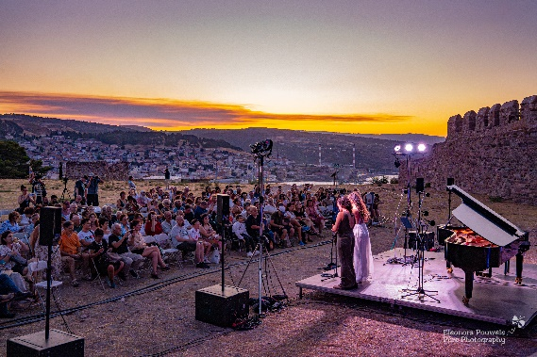
The internationally well-connected Dörken sisters have once again secured the participation of a dozen outstanding musicians for the 2026 festival, along with ANIMATO, a local choir from the island. Together, they will perform six concerts: the first three at selected hotspots across Lesbos (August 12, 13, and 16), followed by three in the picturesque village of Molyvos on the north coast, which gives the festival its name (August 17, 18, and 19). In addition, there will be a concert for young people and nine Molyvos Musical Moments (MMMs), the already legendary 10 to 15-minute short concerts performed throughout the day at various surprise locations in Molyvos (at the beach, harbour, market, club, street, etc.), right in the heart of the town.

Every year, the MIMF captivates audiences not only with outstanding musical performances but also with its exceptional programs in unique venues. This year, these include the Mytilene Castle (August 12) and the medieval castle of Agioi Theodoroi in Antissa, the so-called Ovreokastro, in the northwest of the island (August 13, featuring the Philip Glass tribute "Glass for Two" for vibraphone and piano (Danae Dörken and Pascal Schumacher received an OPUS Klassik award in 2025 for the recording of the same name), as well as the Museum of Industrial Olive Oil Production in the village of Agia Paraskevi (August 16, featuring the choral work "I eat the Sun and Drink the Rain" by Sven Helbig, who will also contribute the electronics on the night). Following this, three concerts will be held in the Seafront Park of the Delfinia Hotel in Molyvos, offering unobstructed views of the Aegean Sea: the first evening with a classical-romantic repertoire and Igor Stravinsky's suite from "L'Histoire du soldat" for Piano, clarinet and violin (August 17). The following evening features Shostakovich's String Quartet No. 8 in C minor, Op. 110 and Schumann's Piano Quartet in E-flat major, Op. 47, plus a world premiere by Christos Papageorgiou (August 18). On the final evening, the program includes Bach's Double Violin Concerto in D minor, BWV 1043, Schubert's Fantasy for four hands in F minor, D 940, and Mendelssohn's Octet in E-flat major.

This year's performers include, in addition to the two exceptional pianists Danae and Kiveli Dörken, violinist Antje Weithaas, who was awarded the OPUS Klassik 2025 as "Instrumentalist of the Year", Tomoko Akasaka and Rachel Roberts, considered leading violists in Europe, the OPUS Klassik 2021 prize winner Benedict Kloeckner on cello and Sebastian Manz, the current solo clarinettist of the SWR Symphony Orchestra.
“For Aristotle, ΕΥΔΑΙΜΟΝΙΑ represents the highest form of human happiness and a fulfilled, virtuous, and therefore "meaningful" life. The focus here is on understanding happiness not as a short-term pleasure, but as a lifelong development of one's abilities and virtues. In today's fast-paced age of technological progress, social media, and performance pressure, this ancient idea reminds us that true contentment arises from inner balance, ethical conduct, and authentic relationships.“ Danae & Kiveli Dörken

As Der Tagesspiegel wrote about the festival ten years ago under the headline "A Vision for Europe": "Danae and Kiveli Dörken wanted to do something for their second home, Greece. That's not necessarily a political idea in itself. They stumbled into the refugee crisis with their small, exquisite festival. Their euphoric energy seemed out of place in the general mood. But it quickly became clear that people, not just on the island, needed exactly this. That it was right and good." In 2026, this "musical immersion" in the immediate daily reality of the people on Lesbos seems no less necessary, right, and good. The Dörken sisters, brimming with energy and ingenuity, and their musical collaborators successfully conjure the magic of this Aegean pearl every year, and so moments of happiness at the 2026 festival are, if not guaranteed, then certainly "πιθανόν," meaning highly probable.

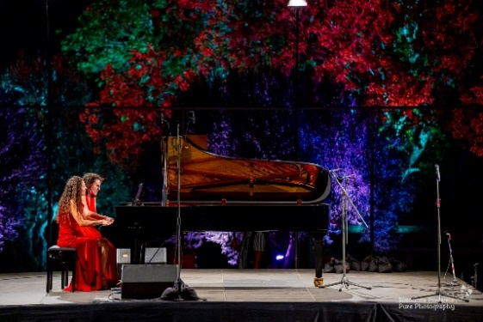
The Molyvos International Music Festival (MIMF) was founded in 2015 by Danae and Kiveli Dörken as a unique project in the northern Aegean, bringing together international artists for a multi-day celebration of classical music. Several renowned musicians participate regularly, such as violinist Antje Weithaas. Many are returning performers, like clarinettist Sebastian Manz, but there are always newcomers and young talents, primarily from Germany and mainland Greece.

“Danae and Kiveli have a knack for choosing the right musicians and the perfect repertoire,” says Antje Weithaas. “We work hard, and we enjoy the beautiful views, the sea, and the parties.”

The Molyvos Festival is no longer a secret in the international press. Its high artistic quality and special atmosphere have become widely known. "With finely spun phrases and an exquisite tone, the performance would be worthy of Wigmore Hall," writes the British music magazine The Strad. And the Frankfurter Allgemeine agrees: "This blend of high skill and uninhibited curiosity is characteristic of the island festival, where first-rate instrumentalists perform in a relaxed holiday atmosphere without compromising their musical ethos."
The Molyvos International Music Festival is supported by the Embassy of the Federal Republic of Germany in Athens, Fraport Greece, Yamaha, and numerous private companies and individuals. The Friends of the Molyvos International Music Festival Association, based in Düsseldorf, makes a significant contribution.
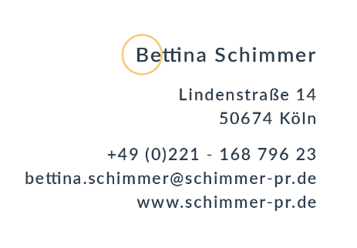

concert overview
ΕΥΔΑΙΜΟΝΙΑ / HAPPINESS 12. – 19 August 2026

12.8. Wisdom (Sophia) – Mitilini Castle
Works by Bach, Paganini, Ysaÿe and Fuchs

13. 8. Temperance (Sophrosyne) - Medieval Castle of Agioi Theodoroi (Ovreokastro) in Antissa
GLASS for TWO with Danae Dörken & Pascal Schumacher

16. 8. Equilibrium (Isoropia) - Museum of Industrial Olive-Oil Production of Lesvos in Agia Paraskevi
“I eat the Sun and Drink the Rain” with Sven Helbig and the ANIMATO Choir from Lesbos

17. 8. Virtue (Areti) - Delfinia Hotel - Seafront Park
Works by Baermann, Weber and Beethoven

18. 8. Courage (Andreia) - Delfinia Hotel - Seafront Park
Works by Shostakovich and Schumann

19. 8. Eudaimonia (Eudaimonia) - Delfinia Hotel - Seafront Park
Works by Bach, Schubert and Mendelssohn

More information: www.molyvosfestival.com

CAST

Violin
Antje Weithaas
Clemence de Forceville
Simos Papanas
Abigél Králik
Kalliopi Rigou
Antonis Mandylas

Viola
Tomoko Akasaka
Rachel Roberts

Violoncello
Benedict Kloeckner
Andreas Brantelid

Clarinet
Sebastian Manz

Piano
Kiveli Dörken
Danae Dörken

Percussion
Pascal Schumacher

Composer
Sven Helbig (Live Electronics)
Christos Papageorgiou

Song
ANIMATO choir

